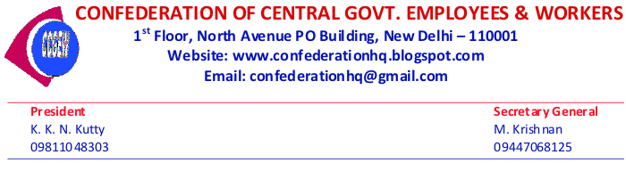

***Dated : 05th January,2017***

***To***

***(1) All National Secretariat Members***

***(2) Chief Executives of all Affiliated Organisations***

***(3)General Secretaries of all C-O-Cs***

***Dear Comrades,***

***As Assembly elections to five States are scheduled to be held from February 4th to March 11th (including declaration of results) and as February 15th is also poll date in two states , the National Secretariat of Confederation of Central Government Employees & Workers has decided to postpone the proposed ONE DAY STRIKE on February 15th to  MARCH 16th 2017 THURSDAY.***

***As 13th March is holiday for Holi in North India and the celebrations are to continue on 14th also, the strike date is fixed as 16th March. There is no change in the 10th January Mass Dharna Programme.***

***All those Organisations who had served the strike notice as February 15th shall give a letter to their Head of the Departments intimating the postponement of the strike to 2017 March 16th ,  showing  reasons as mentioned above ,  WITHOUT FAIL.***

***Those organisations who have not yet served the Strike Notice should serve the notice before 15th January 2017 WITHOUT FAIL.***

***Regarding already announced campaign programme of National Secretariat members , if necessary , dates may be rescheduled by the National Secretariat members in consultation with the concerned C-O-Cs.***

***General Secretaries of C-O-Cs are also requested to contact IMMEDIATELY, the concerned National Secretariat members and finalise the date of campaign programme. Intensive campaign should be conducted by all C-O-Cs and Affiliated Organisations in all States, especially in those states where elections are declared, so that employees and general public will become aware of the totally negative attitude of the Central Government towards the legitimate demands of the Central Government Employees and Pensioners.***

***The betrayal of the Group of Cabinet Ministers of NDA Govt by not fulfilling their assurance given to NJCA leaders on 30th June 2016, should be exposed.***

***M.Krishnan,***

***Secretary General ,***

***Confederation of Central Government Employees & Workers.***

***Mob & Whats App: 09447068125.***

***Email : mkrishnan6854@gmail.com***